Charlotte

# Concept

Landmines were originally intended as a defence against the Mongols to save cities (Who Invented, 2011), and were first used as an anti-vehicle device to combat Tanks in WW1. Widespread personnel Techniques prompted the implementation of rings of specially designed “anti-personnel” mines. Egypt reportedly remains the most heavily mined country since WW2 (Jones, M., 2021).

Landmines are viewed as inhumane by most NATO countries and some have campaigned against their use (International Campaign to Ban Landmines, 2022). Russia has endangered Ukrainian Civilians using landmines (Human Rights Watch, 2022). The 1997 Ottawa Anti-Personnel Mine ban which was accepted by 164 countries aims to forbid the use of the production, stockpiling or use of anti-personnel mines (Finabel European Army Interoperability Centre, 2019).

Landmine removal involves ground preparation machines to soften the soil, neutralizing tripwires and the removal of small trees, bushes, shrubs and grass. Safe lanes are marked out to provide safe access to minefields via deminers with metal detectors. Rats are then deployed to detect the scent of explosives. This takes 30 minutes in comparison to 4 days by conventional manual deminers. After the rat indicates the presence of an explosive the deminer arrives to excavate and confirm the marked position. The mine is detonated, and after the land is assessed to be cleared of mines and safe for community use, the land is then returned to the landowners (APOPO 2022).

# Project Aims

The aims are to create a robot that is not only automatic in its movement but also can detect foreign metal explosives via sensors. The robot may “flag” sites at which it has detected a potential explosive and send the coordinates via text message or similar communication to the deminer. Object avoidance and pathfinding are hoped to be implemented for the robot to adapt to the changing environment. This project aims to develop a robot vehicle with the intention of safe deactivation of mines lying dormant underground.

Charlotte would consist of a Light build, would be automatic in movement, feature a variety of sensors to detect landmines, Motor and Sensor Calibration, Aluminium and Steel for the Chassis, C/C++ programming, Github considered for file storage and backup, Agile Methodologies allowed for Project management of the project.

# The Artefact

Screenshot from Fusion360 of Prototype (Front View)

* ELEGOO Mega2560
* Haljia Metal Detector Module
* Node MCU WiFi Lolin V3 ESP8266
* ADXL335 Accelerometer
* 3x HC SR-04 Ultrasonic Sonar Sensors
* VEX V4 Clawbot Kit
* 3x 7.2V VEX batteries
* 3x VEX Integrated Encoder Modules
* Breadboard with Kit
* Wire Block Terminal
* Heat Shrink Solder Connectors
* Crimping Tool Set
* 3D Printed Chair
* Acrylic Mounts

Total Cost: £352.95

Total Weight: 3.3kg

# Method

The research for Charlotte involved use of Qualitative and Quantitative research and adopted two Agile Methodologies.

ML Modified Agile Feature Approach

The above figure demonstrates my modified ML Agile Feature Approach

This methodology is used to ensure meetings go as planned. Meetings are kept short and to the point. Task allocation was not considered by the supervisor as they were not involved in the planning of the project. This ensures good rapport and project progression. The methodology was based on the “ML Agile Feature” process focusing on requirement gathering and feedback. (Wilson, B., 2022, ch. 2.3.1).

Scrum

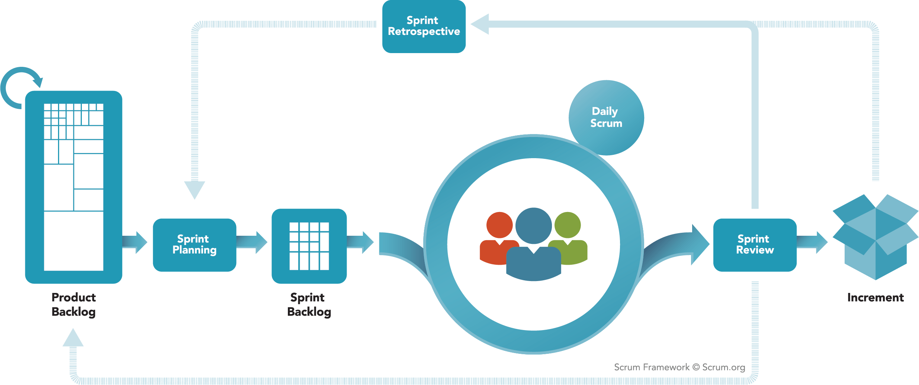

Scrum Framework used in Agile provided by the Scrum.org website (Scrum.org, 2022). Refer to first Figure on Website.

Scrum was adopted to keep my project on track and ensures the completion of tasks. This adopted the use of Sprint Planning, Daily Scrum, Sprint Reviews, Sprint Retrospective, Product Backlog and Sprint Backlog.

Furthermore, the planning involved use of a Gannt Chart, ProjectLibre was used for the purpose of the project sprints and Trello was used to keep tracks of tasks via use of Kanban boards.

Gear trains were made use of to drive the gears at a desired speed needed to drive the robot. The robot made use of turning point drives (a VEX styled command) used to turn corners. Sonars emit sounds that bounce off surfaces that can then be picked up to determine distances via speed. Metal is detected through electrical signals which is reliant on objects with magnetic properties.

Different Gear Ratios (Bringardner, J., 2022). Refer to Figure 1-18 on webpage.

VEX Robotics demonstrating a turn using the front and back wheel (VEX Robotics, 2023) refer to third Figure on webpage.

A Ultrasonic Range Finder diagram demonstrating Sonar Detection off a flat object, Image provided by (VEX Robotics, 2012) refer to second figure on webpage.

## Flowchart of Prototype

Screenshot of Prototype flowchart(Cropped from bottom)

Screenshot of Prototype flowchart(Cropped from top)

Screenshot of Arduino Output and Recording of Robot demonstrating potential Mine grid detection (The robot has detected and flagged a mine’s location successfully)

Screenshot of Arduino Output and Recording of Robot demonstrating potential Mine grid detection (The robot has successfully finished completion of the grid and has provided co-ordinates

# Findings

The Robot moves roughly as designed: moving within a grid. The requirements could not all be met due to the limitations of the modules involved – if time and money were not a factor, the project may have been better implemented. Charlotte however does meet the aims of being light enough for mine clearance as the robot weighs 3.3kg which is well under the 30kg target. Also the cost of Charotte totals to £352.95 just under NevonProject’s robot for £379.17.

# Conclusion

Charlotte’s avoidance has the potential to be improved and while the student lacks the knowledge to fully understand how to network the ESP8266 currently, the student recommends further research could be looked into the client/website side of things. The student also felt the device could have had local storage attached so there was a more reliable means to ensure that the data could be logged for debugging purposes and the robot could adopt Artificial Intelligence via a Arduino Camera to map the room for Object avoidance.

The Project despite drawbacks was a success but the project needs much more work to be considered a complete project from the student’s perspective – the student involved wishes to continue research into making a better version of the project at a later date but is satisfied to conclude that the project met most requirements.

Some planned ideas for improvements of this project include Path Finding with Artificial Intelligence, Camera implementation, Internet Application to store and show co-ordinates and status of Charlotte.

# Impact

The research promotes the fundamental basics of physics, a better understanding of Arduino, CAD Design, improved project planning, evaluation skills and brought awareness of the dangers of landmines. On Reflection, this has made me enthusiastic about robotics and made me better understand Software Development principles when it comes to development of projects. Given more experience: I feel I would be able to manage projects more efficiently and thanks to my understanding of robotics could innovate new ideas for the field of robotics.

# References

APOPO (2022) *Mine Clearance*, Available at: <https://apopo.org/what-we-do/detecting-landmines-and-explosives/how-we-do-it/mine-clearance/?v=f214a7d42e0d> (Accessed: 14/10/2022)

Bringardner, J. (2022b) *Motion* Available at: <https://manual.eg.poly.edu/index.php/VEX_How-To_Manual#Motion> (Accessed: 14/01/2023)

Finabel European Army Interoperability Centre (2019) *Smart Mines: The Future Battlefield?*, Available at: <https://finabel.org/smart-mines-the-future-battlefield/> (Accessed: 14/10/2022)

GICHD (2022) *Clearing landmines from Ukraine may take decades,* Available at: <https://www.bing.com/ck/a?!&&p=f0fa091030ac2897JmltdHM9MTY4NjE4MjQwMCZpZ3VpZD0zYWY2ZDFkNC03ZWU1LTY5MTAtMDE1My1jM2Y5N2Y1ZTY4OWQmaW5zaWQ9NTIyNQ&ptn=3&hsh=3&fclid=3af6d1d4-7ee5-6910-0153-c3f97f5e689d&psq=80%2c000+ukraine+GICHD%2c+2022&u=a1aHR0cHM6Ly9yZWxpZWZ3ZWIuaW50L2F0dGFjaG1lbnRzLzNjZThkZjY5LWRkZmQtM2YwZi05YjMzLWQ2Y2U5ODY0N2UwZS9QcmVzc1JlbGVhc2VfR0lDSERfQ2xlYXJpbmdMYW5kbWluZXNJblVrcmFpbmVNYXlUYWtlRGVjYWRlc19NYXkyMDIyLnBkZg&ntb=1>(Accessed: 08/06/2023)

Human Rights Watch (2022) *Ukraine: Russian Landmine Use Endangers Civilians*, Available at: <https://www.hrw.org/news/2022/06/15/ukraine-russian-landmine-use-endangers-civilians> (Accessed: 10/10/2022)

International Campaign to Ban Landmines (2022) *A Global Network Working For A World Free Of Landmines*, Available at: <http://www.icbl.org/en-gb/home.aspx> (Accessed: 10/10/2022)

Jones, M. (2021) *What is a landmine?*, Available at: <https://aoav.org.uk/2021/what-is-a-landmine/> (Accessed: 10/10/2022)

Scrum.org (2022) *What is Scrum?*, Available at: <https://www.scrum.org/resources/what-is-scrum> (Accessed: 21/12/2022)

VEX Robotics(2012) *Sensor Accessories Ultrasonic Sensor,* Available at: <https://content.vexrobotics.com/docs/instructions/276-2155-instr-0312.pdf> (Accessed 07/02/2023)

VEX Robotics(2023) *Drivetrain Terminology,* Available at: <https://curriculum.vexrobotics.com/curriculum/drivetrain-design/drivetrain-terminology.html> (Accessed: 14/01/2023)

Wilson, B. (2022) Machine Learning Engineering in Action, Available at: <https://learning.oreilly.com/library/view/machine-learning-engineering/9781617298714/> (Accessed: 03/11/2022)

Who Invented (2011) *Who invented landmines?,* Available at: <http://www.whoinvented.org/who-invented-landmines/> (Accessed: 10/10/2022)